RETURNING DTO (Data Transfer Object)

- Under application module, create a new folder under restaurants folder called Dtos
- Create a classlibrary name RestaurantsDto.cs under Dtos folder
  - Copy paste Restaurants.cs entity to RestaurantsDto.cs
  - Remove contact number and email because we don’t want to share that
  - Change Dish entity to DishDto in the new file
  - Add the public static class at the end
- Create a new folder under application module called Dishes
  - Create a new folder under Dishes called Dtos
  - Create a new classlibrary called DishDto.cs under Dtos folder
  - Copy and pastes the Dish.cs without RestaurantID because we don’t want that
  - Add the public static class at the end
- Change Restaurant to RestaurantDto in IRestaurantsService.cs
- Edit RestaurantsService.cs
  - Add static FromEntity method to convert Restaurant Entity in the database to RestaurantDto
- Done for Restaurant. If want to include dish must edit at RestaurantRepository.cs
  - Add include method to include dishdto entity
- Make sure RestaurantDto.cs have dishes part in public static from entity
- Run and see the data that appear in the web api

STEP BY STEP TUTORIAL

- Under application module, create a new folder under restaurants folder called Dtos
- Create a classlibrary name RestaurantsDto.cs under Dtos folder
  - Copy paste Restaurants.cs entity to RestaurantsDto.cs
  - Remove contact number and email because we don’t want to share that
  - Change Dish entity to DishDto in the new file
  - Add the public static class FromEntity at the end
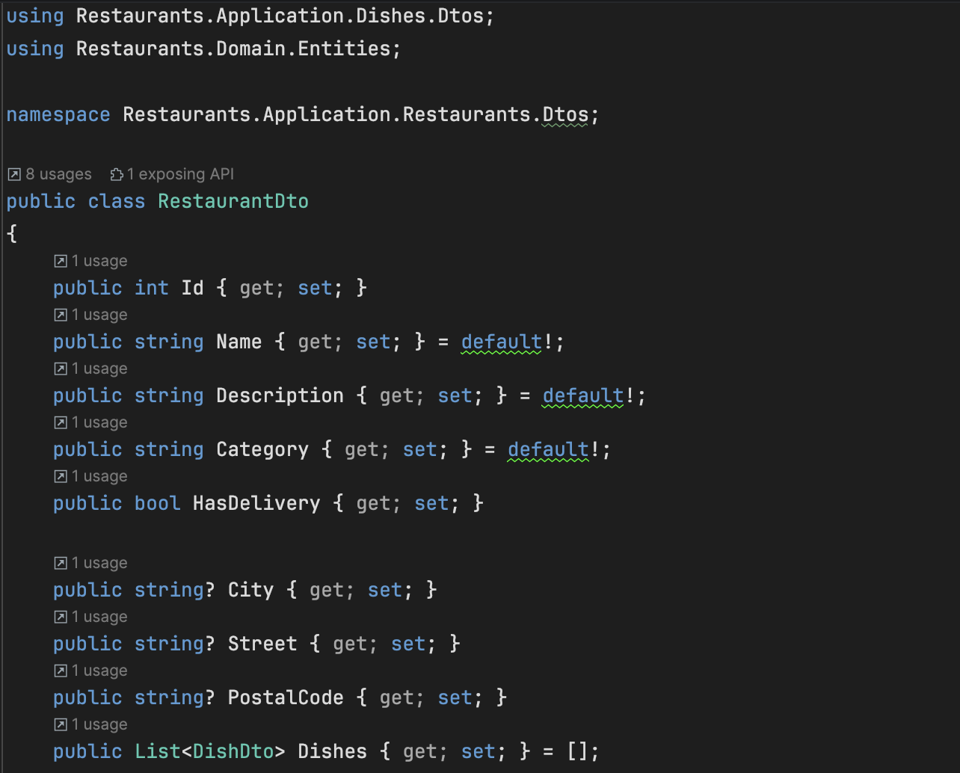
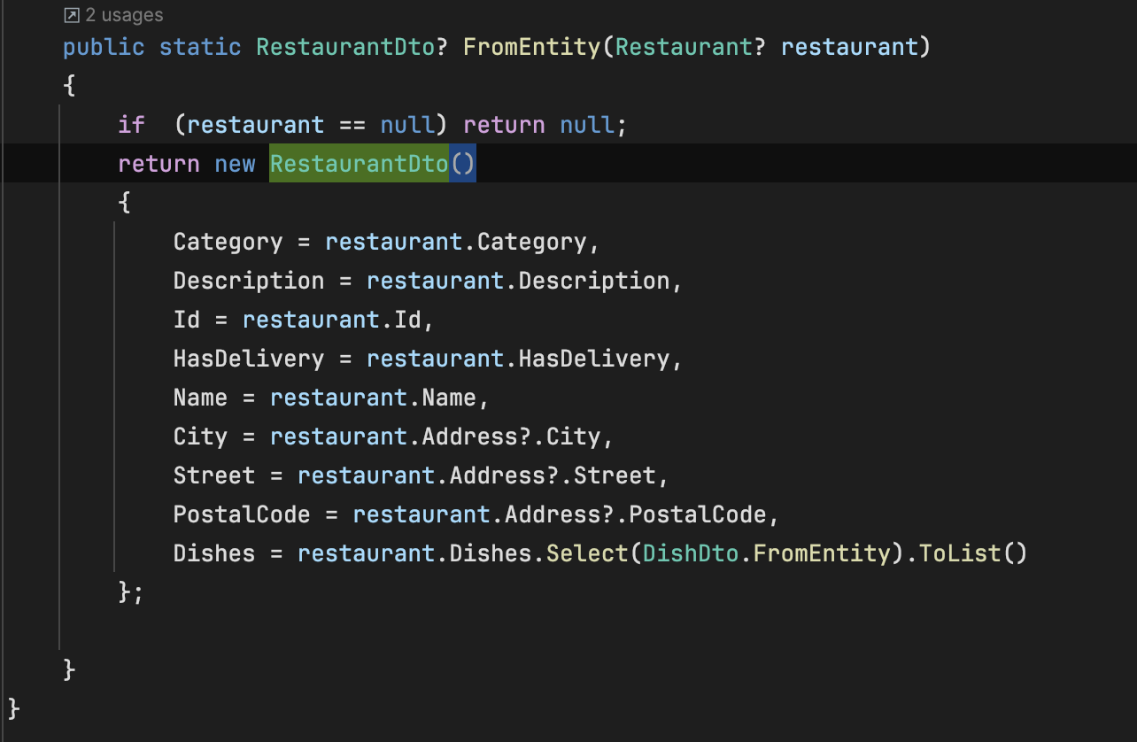

- Create a new folder under application module called Dishes
  - Create a new folder under Dishes called Dtos
  - Create a new classlibrary called DishDto.cs under Dtos folder
  - Copy and pastes the Dish.cs without RestaurantID because we don’t want that
  - Add the public static class FromEntity at the end
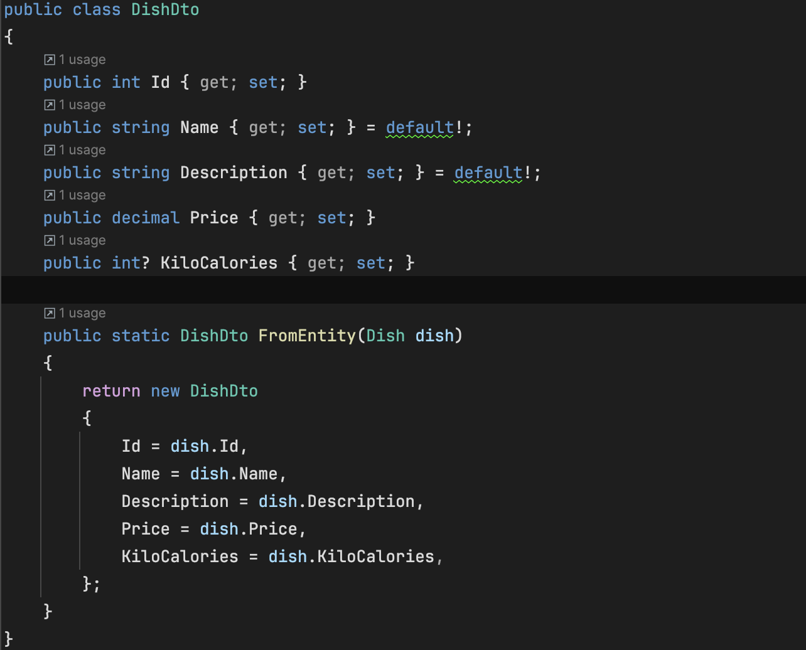

- Change Restaurant to RestaurantDto in IRestaurantsService.cs
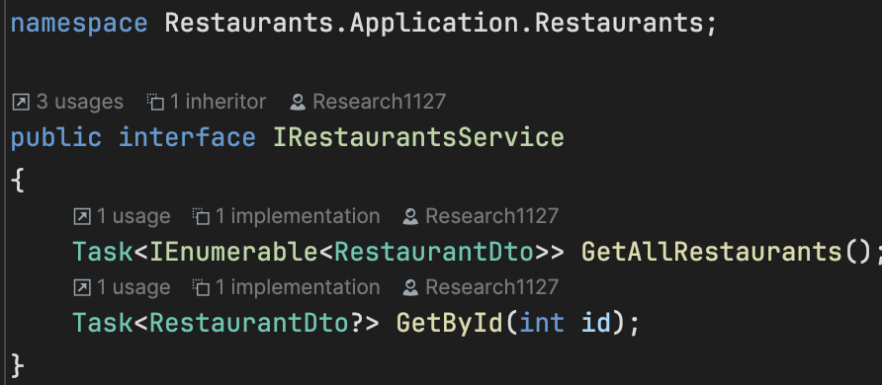
- Edit RestaurantsService.cs
  - Add static FromEntity method to convert Restaurant Entity in the database to RestaurantDto
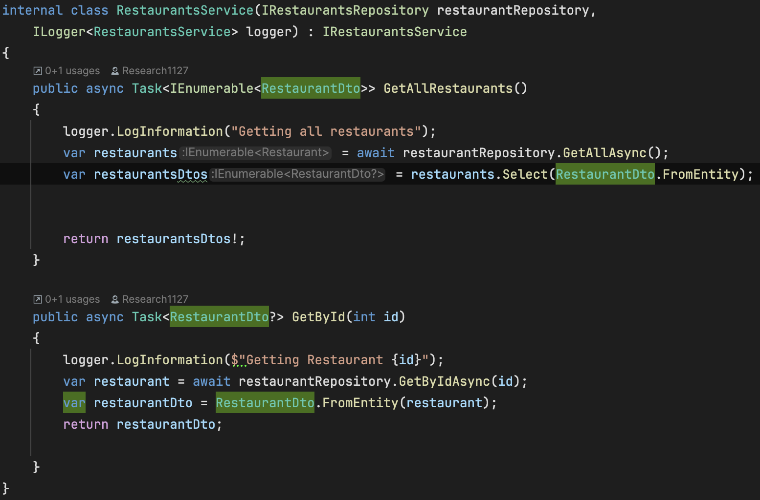

- Done for Restaurant. If want to include dish must edit at RestaurantRepository.cs
  - Add include method to include dishdto entity
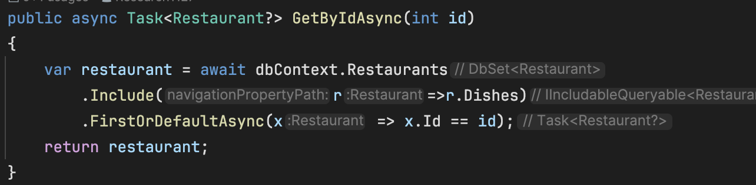
- Make sure RestaurantDto.cs have dishes part in public static from entity
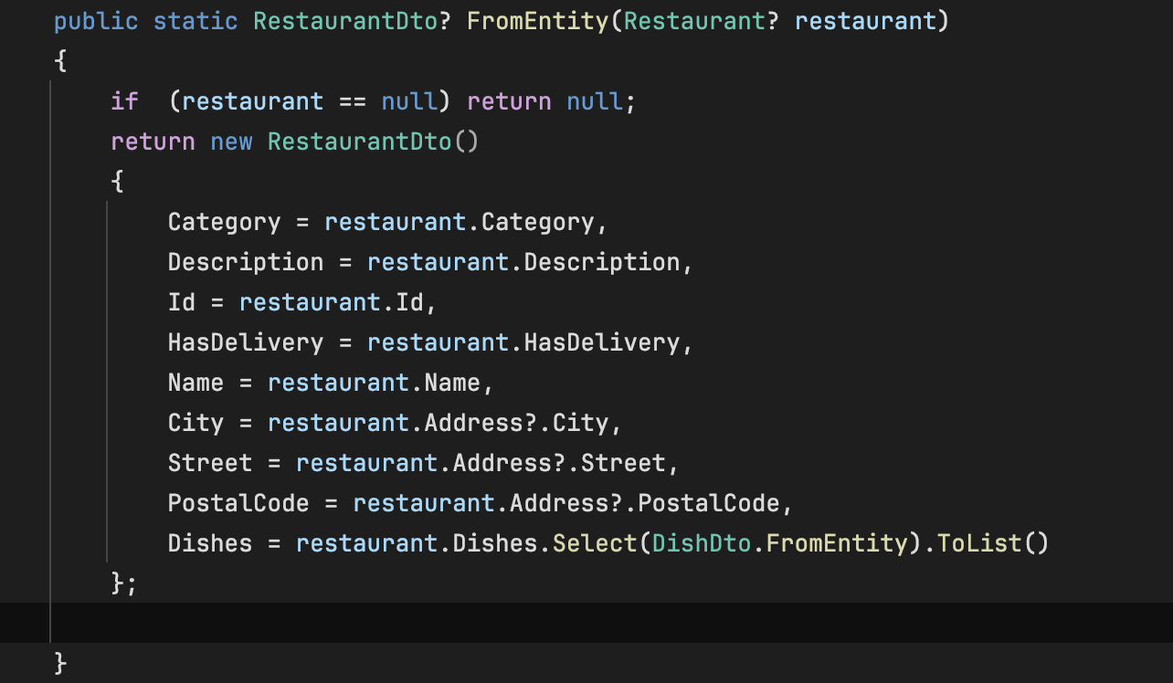
- Run and see the data that appear in the web api

- This is the result in swagger
